COGNETIX GLOBAL TECHNOLOGY LLP
Cybersecurity Internship – Level 1 Project 3
Password Security Analysis and Hashing

Prepared by: Ishwari Ajaykumar Patil
Intern ID: CT/CS/X156
Remote Cybersecurity
Internship Date: 30 June 2026

- Introduction

Password security is one of the most critical components of cybersecurity as weak authentication mechanisms can lead to unauthorized access and data breaches. Many users tend to create weak or reused passwords, which significantly increases security risks.

In this project, a password dataset was analyzed using Python to evaluate password strength, detect password reuse, and assess security patterns. Additionally, password hashing techniques using bcrypt were applied to convert plaintext passwords into secure hashed formats. Visualizations were generated to better understand password behavior trends.

The goal of this project is to analyze password security weaknesses and demonstrate how hashing improves data protection in real-world systems.

- Objective

The primary objective of this project is to analyze password security and implement hashing techniques to improve data protection.

The objectives include:

- To analyze password strength distribution
- To identify reused passwords in the dataset
- To compute password length and strength score relationships
- To apply bcrypt hashing to secure plaintext passwords
- To compare plaintext and hashed passwords
- To visualize password security patterns using graphs
- To generate security findings based on analysis

- Tools and Environment

The following tools and environment were used:
- Python 3.x
- Jupyter Notebook
- Pandas Library
- Matplotlib Library
- bcrypt Library
- Windows Operating System
- CSV Dataset (Password Dataset)

- Methodology

Step 1 – Data Loading and Inspection

The dataset was loaded using Pandas and initial inspection was performed to understand its structure.

Command:

df.head()

Purpose:
To display the first few rows of the dataset and understand available columns.

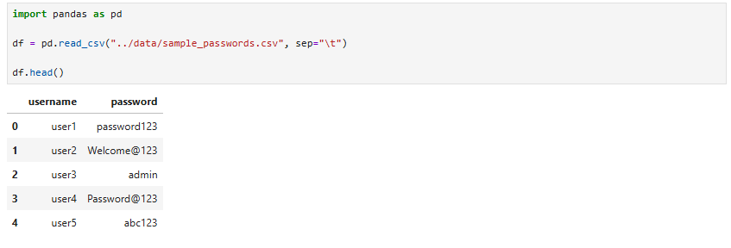

Step 2 – Password Frequency Analysis

Password reuse frequency was analyzed using value counts.

Command:

df['password'].value_counts()

Purpose:
To identify repeated passwords in the dataset.

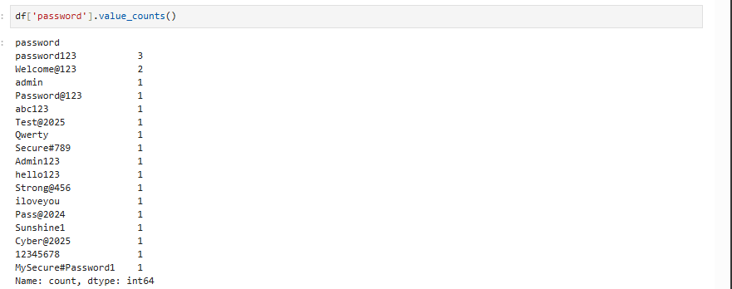

Step 3 – Password Strength Analysis

Password strength distribution was analyzed.

Command:

df['Strength'].value_counts()

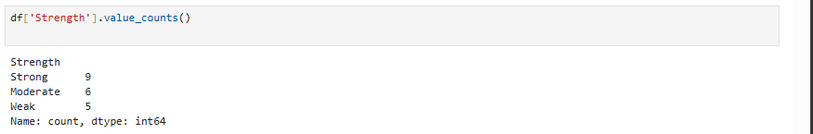

Step 4 – Password Hashing

Passwords were converted into secure hashed format using bcrypt.

Command:

import bcrypt
def hash_password(password):
return bcrypt.hashpw(password.encode(), bcrypt.gensalt()).decode()
df['Hashed Password'] = df['password'].apply(hash_password)

Purpose:
To secure plaintext passwords using hashing algorithm.

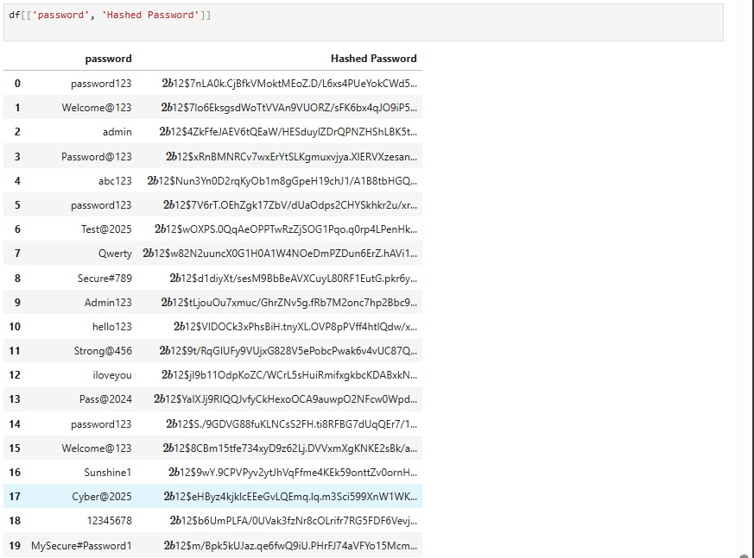

Step 5 – Password Length Calculation

Password length was calculated for analysis.

Command:

df['Length'] = df['password'].apply(len)

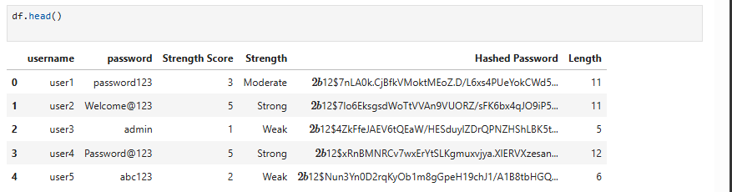

Step 6 – Data Visualization

Chart 1 – Password Strength Distribution

df['Strength'].value_counts().plot(kind='bar')
plt.title("Password Strength Distribution")
plt.xlabel("Strength")
plt.ylabel("Count")
plt.savefig("reports/password_strength.png")
plt.show()

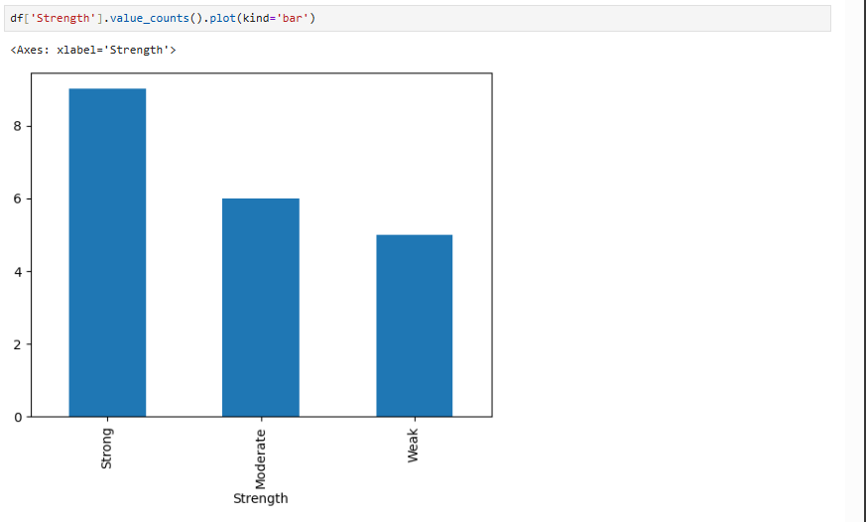

Chart 2 – Password Length vs Strength Score

plt.scatter(df['Length'], df['Score'])
plt.title("Password Length vs Strength Score")
plt.xlabel("Password Length")
plt.ylabel("Score")
plt.savefig("reports/password_length.png")
plt.show()

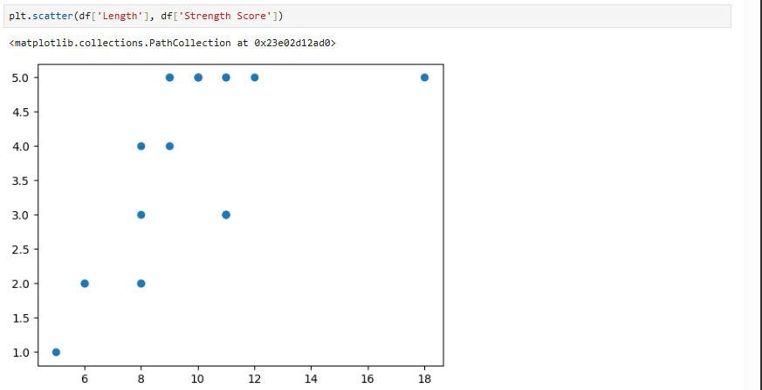

Chart 3 – Password Reuse Frequency

df['password'].value_counts().plot(kind='bar')
plt.title("Password Reuse Frequency")
plt.xlabel("Password")
plt.ylabel("Count")
plt.savefig("reports/reuse_frequency.png")
plt.show()

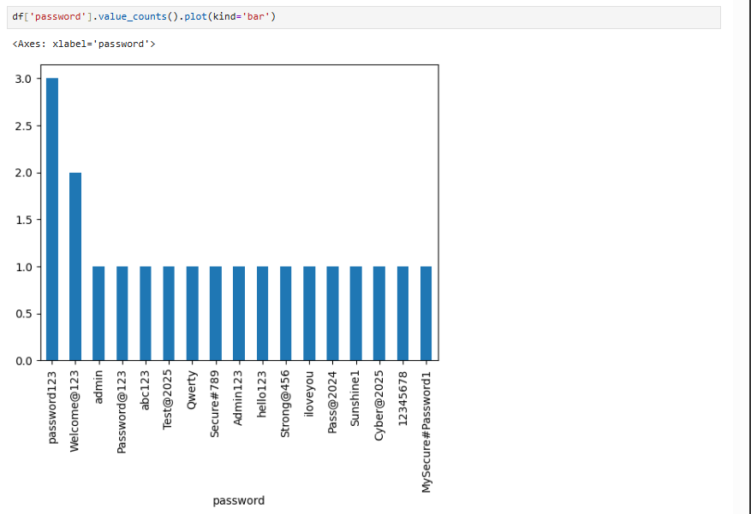

- Results

The analysis produced the following results:
- Weak passwords were present in the dataset
- Several passwords were reused multiple times
- Strong passwords showed higher strength scores
- Password hashing successfully converted plaintext into secure format
- Password length positively influenced strength score
- Visualizations helped identify security patterns clearly

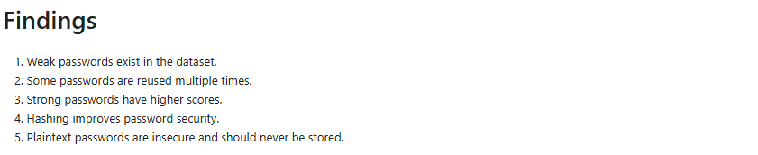

- Security Analysis

The dataset analysis revealed significant password security issues. Weak passwords and reused credentials increase vulnerability to brute-force and credential stuffing attacks.

Password hashing using bcrypt significantly improves security by ensuring that plaintext passwords are not stored directly. Even if data is compromised, hashed passwords cannot be easily reversed.

The analysis also showed that stronger passwords tend to have higher complexity and length, reinforcing the importance of strong password policies.

- Conclusion

The Password Security Analysis project successfully demonstrated how password strength evaluation, reuse detection, and hashing techniques can improve cybersecurity practices.

The study highlights the importance of strong password creation, avoidance of reuse, and secure storage using hashing algorithms. The use of visualization further enhanced understanding of password security trends.

Overall, this project provided practical experience in data analysis, cybersecurity fundamentals, and secure password handling techniques using Python.

